
How To Use ClassDojo
Parents and Carers,
As you may already know, we want to make sure your children have plenty to keep
them occupied while they cannot come to school. We want to ensure they are still
learning and making progress, and we’d love to stay in touch with them during this tricky period which is so to what we are used to!
As a school, and like thousands of other schools up and down the country, we have chosen to use a learning platform (an App) called ClassDojo. Most of our children know about it since many classes use it to keep points for individual children. Reception and Year 1 classes use it every day for communication between school and home.
Like YR and Y1, the class teachers will upload activities, challenges and learning tasks for the children to do independently or with adult support. Staff will also post links and information about interesting websites you might like to use and so on.
It’s also the perfect way for staff to stay in touch. We care about you and your children and want to know that you’re all ok through this difficult time .
Before the children left school, many of them were given a log on sheet with a personalised code which is unique for your child.
It will look a bit like this:
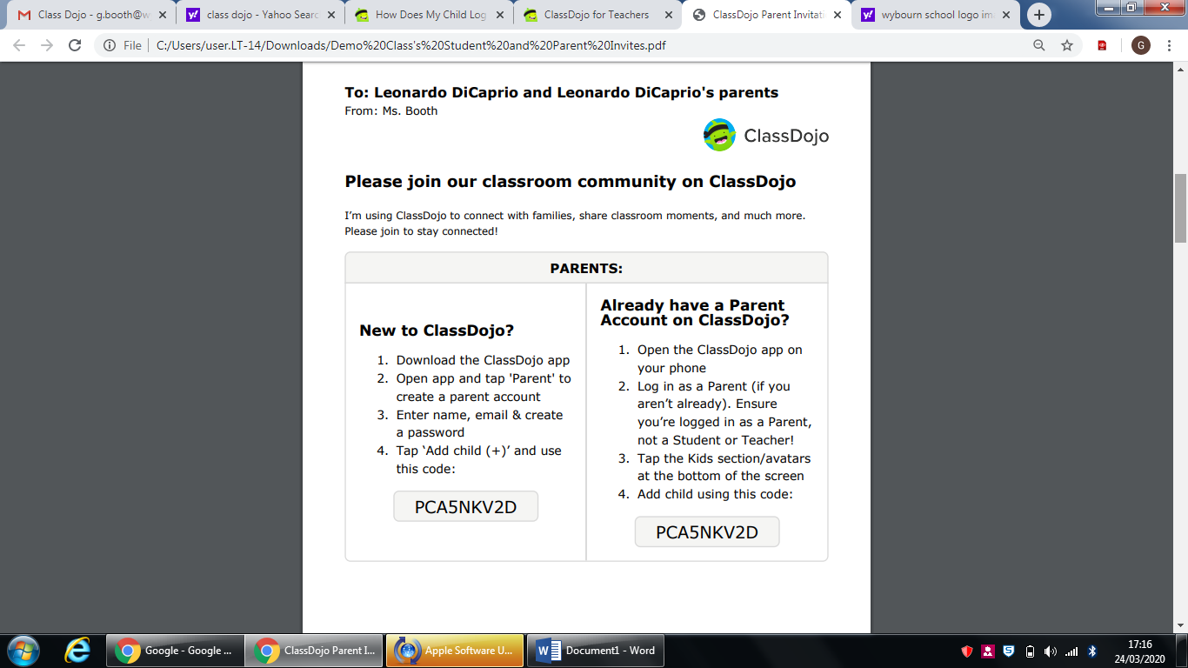
If you didn’t get one of these, please ring the school this Thursday (26th March), and I’ll access your child’s code and get it to you.
Alternatively, you may have received a text from school with a unique code. If you haven’t accessed ClassDojo yet, another text will be sent to you on Thursday.

Use the code in that text to follow these instructions, after you’ve downloaded the ClassDojo App from the App store (for free).

To Create a Parent Account with a Parent Code:
- Go to home.classdojo.com
- Select “Parent” from the center of the screen
- 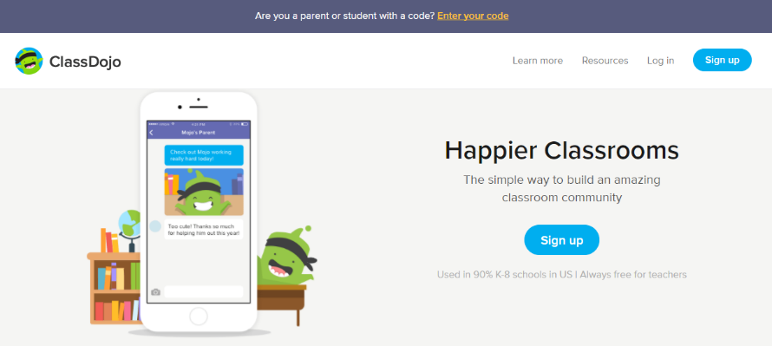
Enter your parent code and select “Check code” and Click on "I'm ___'s Parent" OR select “Sign up,” enter your first and last name, email address, and create a password before clicking "Sign Up" again
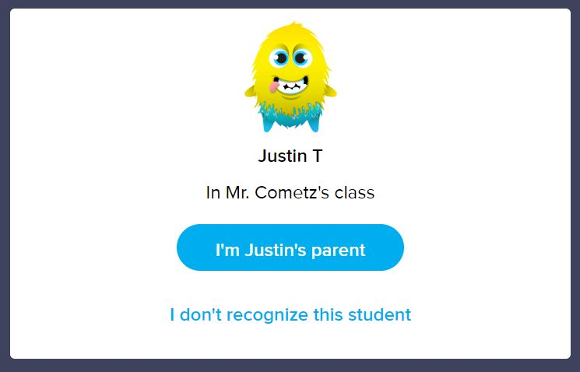

The App itself works very much like Facebook. You can read messages from your child’s teacher, and they will read what you or your child upload or type. It’s best to have a play around and work out what how it works – no doubt your child can give you a crash course in 5 minutes.
If you have a problem, please ring me in school on Thursdays or Fridays and I’ll help you out.
Miss Gill Booth

