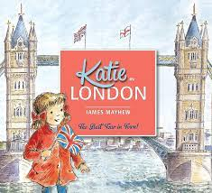
Y1 Homework menu – Bright light Big City
Choose one homework from the below selection to do each week. Dojo points will be given for the effort you put in so let’s get creative!
Can you write some facts about London from what you have learnt at school? You could also do some research on the internet. 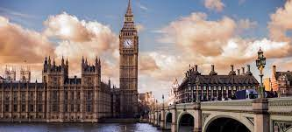
.
Can you draw a picture of a famous London landmark?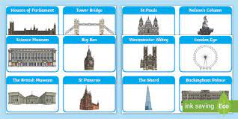
Draw a detail picture of our King- Charles III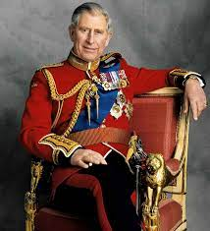

Can you make a model of the United Kingdom? 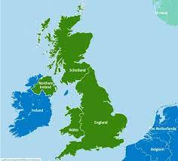

3
2
3
Making a necklace using string, cheerio’s pasta etc..
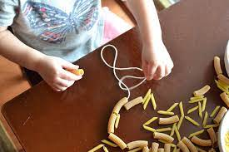
Can you double some numbers to 20?
1 doubled is 2
2 doubled is 4

Can you a collect some objects and then put them into 10’s?
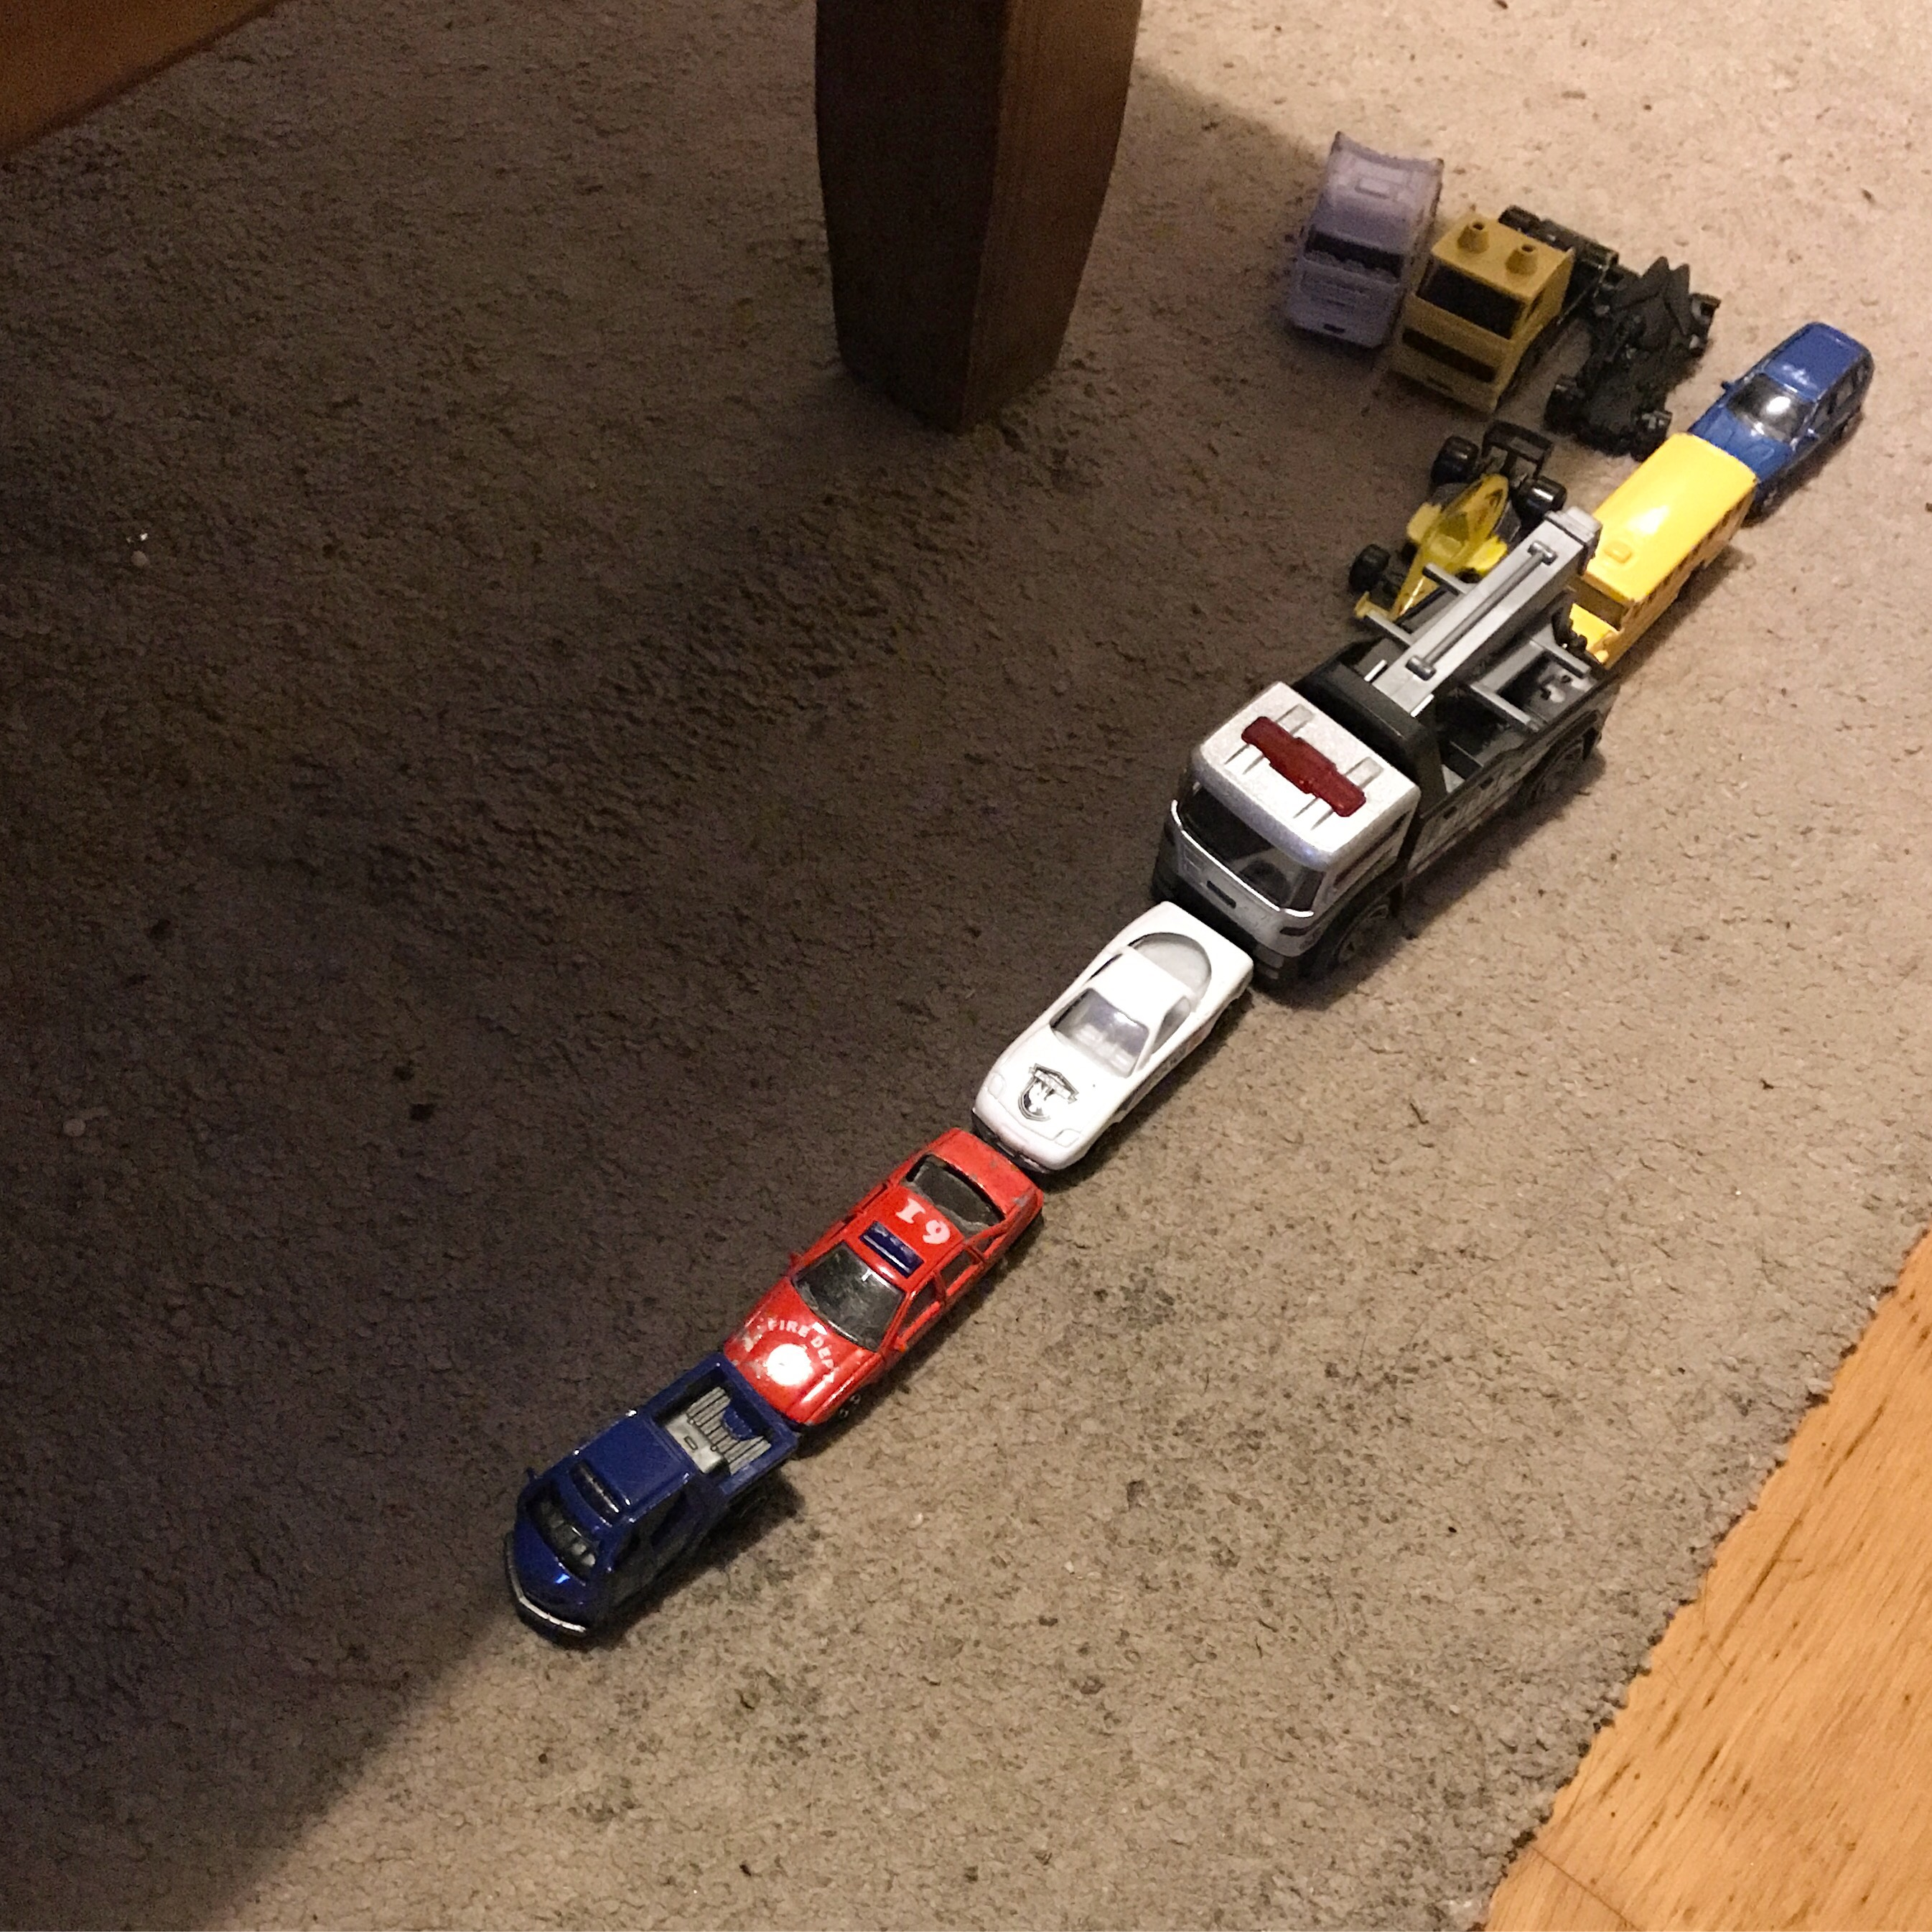
Now practise counting in 10’s to 100
Now can you write these numbers down?
Make sure your numbers are the correct
way round.

4
Seasons
Can you draw a picture of each season?
Winter, Spring, Summer and Autumn
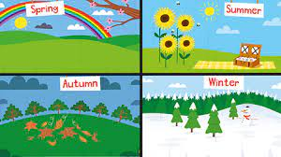

4

Can you draw a picture of a type of weather i.e. rain, sun..

5

4

These are suggestions but if you think of your own feel free to do this! You can look at anything in connection with our topic ‘Bright Lights Big city’ or what you are doing in school at that time!
anything in connection with our topic “Enchanted wood” or what you are doing in school at the time!

