Y2 Homework menu – Coastlines
Choose one homework from the below selection to do each week. Dojo points will be given for the effort you put in so let’s get creative!
Can you write a poster explain the different lifeguard flags?

Can you measure your family? How is the tallest and who is the smallest?

Can you make a flower and a pot?

Can you write some instructions for building a sandcastle?

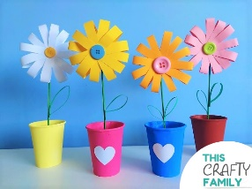
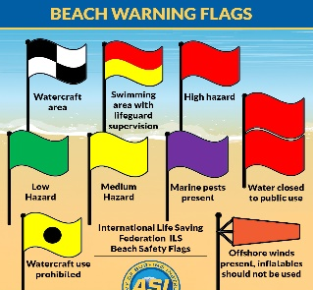
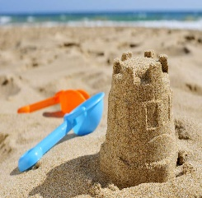
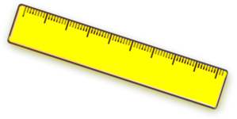
Can you practise adding and subtracting numbers in the hundreds? Example 358 – 234 =?

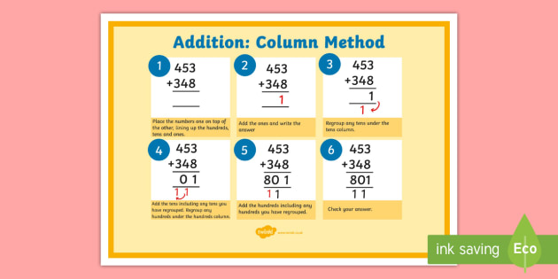
Can you draw a map of the UK and write all the countries that make up the UK? What are their capital cities called?

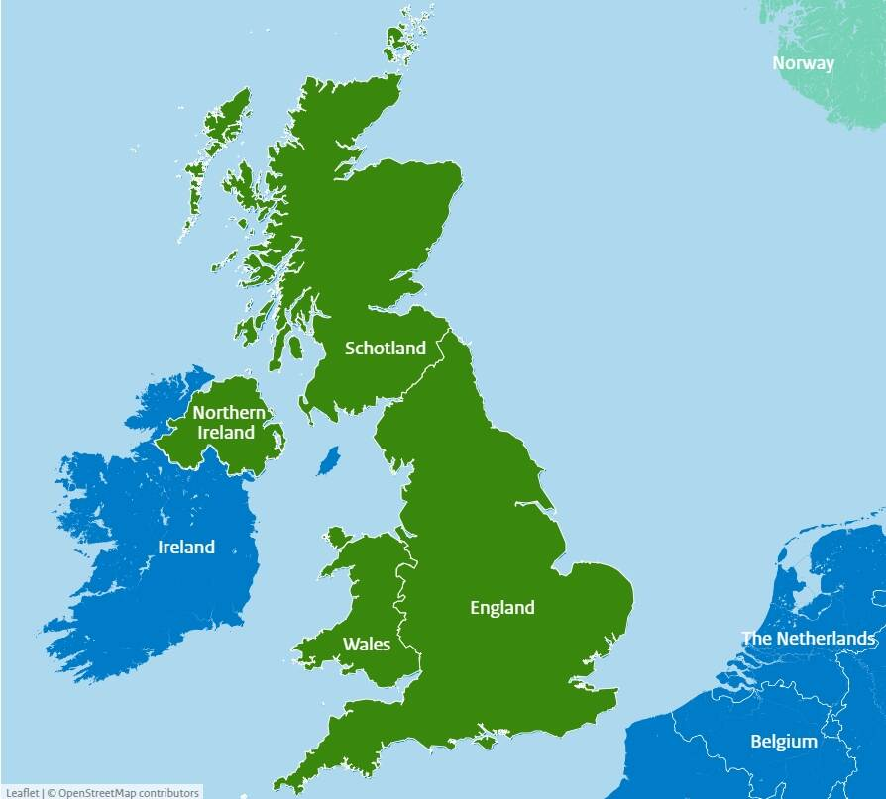

Can you draw a picture of a flower?
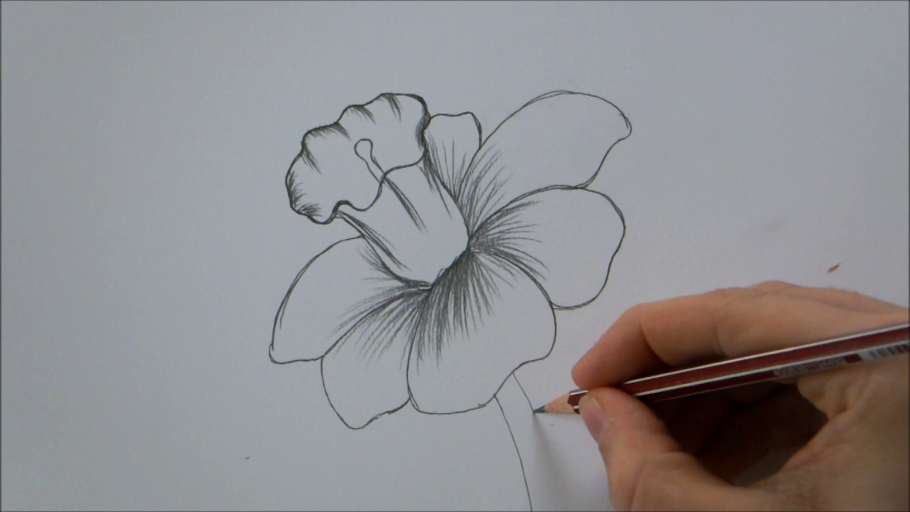

Can you go for a walk and see what flowers you can find? Take photos of the flowers to find out what they are called.

Can you learn to tie your own shoes?
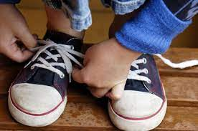

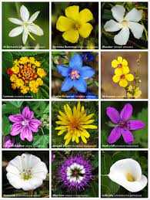
These are suggestions but if you think of your own feel free to do this! You can look at anything in connection with our topic ‘Coastlines’ or what you are doing in school at that time!

These links can be used to help you complete homework tasks, catch up if you’re having to isolate or even if you want to do extra!
Art
https://www.jeyram.org/flowers
Geography
https://www.bbc.co.uk/teach/class-clips-video/geography-ks1-ks2-the-united-kingdom/zhtgrj6
https://www.bbc.co.uk/bitesize/topics/zqj3n9q/articles/zjd66v4
https://www.bbc.co.uk/bitesize/topics/zx882hv/articles/zy38wmn
Literacy https://www.education.com/game/adjectives-quiz/
https://www.bbc.co.uk/bitesize/topics/zgqxwnb/articles/zfrcmfr
Maths
https://www.topmarks.co.uk/Search.aspx?q=fractions+year+2&p=2
https://www.bbc.co.uk/bitesize/topics/zwv39j6/articles/zvr9g7h https://www.ictgames.com/mobilePage/
https://www.topmarks.co.uk/money/toy-shop-money https://www.topmarks.co.uk/maths-games/subtraction-grids

#

